Project Design Phase-II Technology Stack (Architecture & Stack)

|  |  |
| --- | --- |
| Team ID | PNT2022TMID13652 |
| Project Name | Project – Smart waste management system for metropolitan cities |
| Maximum Marks | 4 Marks |

Technical Architecture:

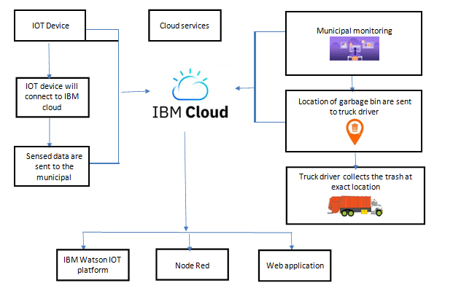

Table-1 : Components & Technologies:

|  |  |  |  |
| --- | --- | --- | --- |
| **S.No** | **Component** | **Description** | **Technology** |
| 1. | User Interface/login | IBM Watson IOT cloud platform | MQTT protocol |
| 2. | Application Logic-1 | Status of the bin is monitored by using sensors | Python |
| 3. | Application Logic-2 | Data are Monitored by using IOT | IBM Watson STT service, IBM Watson IOT platform |
| 4. | Application Logic-3 | Based on the level the bin, message is sent to the trash collectors to clear the Wastes | IBM Watson Assistant, , IBM Watson IOT platform |
| 5. | Database | MySQL- It is database to collect the data  NoSQL-It is an approachto database design that enables the storage and querying of the data outside the traditional  structures found in relational database. | MySQL, NoSQL |
| 6. | Cloud Database | It receives the status of the bin & send the data to the cloud & send it to mobile and web application | IBM DB2, IBM Cloudant |
| 7. | File Storage | It is an easy way to back up and quick recovery to collect the old data. | IBM Block Storage or Other Storage Service or Local File system |
| 8. | External API-1 | External API is exposing a projects internal resource to the outside users. | IBM Weather API, JASON, XML file etc. |
| 9. | External API-2 | It is used to allow you to access the third party. | SOAP API, etc. |
| 10. | Machine Learning Model | It is used to easily identify the location of the bin and find out the shortest path to the bin | Python IDLE, Anaconda navigator or Jupiter, GPS. |
| 11. | Infrastructure (Server / Cloud) | **Server**  In computing, information technology infrastructure is composed of physical and virtual resources that support the flow, storage, processing and analysis of data.  **Cloud**  It includes computing power, networking, and storage, as well as an interface for users to access their virtualized resources.  **Cloud server configuration**  Cloud configuration is the process of setting hardware and software details for elements of a cloud environment to ensure that they can interoperate and  communicate. | Cloud - MySQL server-HTTPS/HTTP,FTP protocol |

Table-2: Application Characteristics:

|  |  |  |  |
| --- | --- | --- | --- |
| **S.No** | **Characteristics** | **Description** | **Technology** |
| 1. | Open-Source Frameworks | Open source framework that can be used either privately or public which includes KAA IOT, kubernetes etc.. | Docker, Kubernetes |
| 2. | Security Implementations | Encryption/Decryption used for security purpose. Firewalls use a rule-based access control model  with rules expressed in an access control list. | VPNs, Encryptions, decryptions etc. |
| 3. | Scalable Architecture | New features can be added  24×7 monitoring system is designed for  monitoring dumpsters | Node red, cloudantDB, jira software |

|  |  |  |  |
| --- | --- | --- | --- |
| **S.No** | **Characteristics** | **Description** | **Technology** |
| 4. | Availability | We access the data in mobile and web application from anywhere .Any person with authority can access the data  Easily by deploying separate clusters over geographically. | Distributed servers, IMS server |
| 5. | Performance | All can access the application at same time.  The Smart Sensors use ultrasound technology to  measure the fill levels (along with other data) in bins several times a day | IBM Watson IOT platform, cloudantDB, javascript CDN |